**War of the Worlds: Learning**

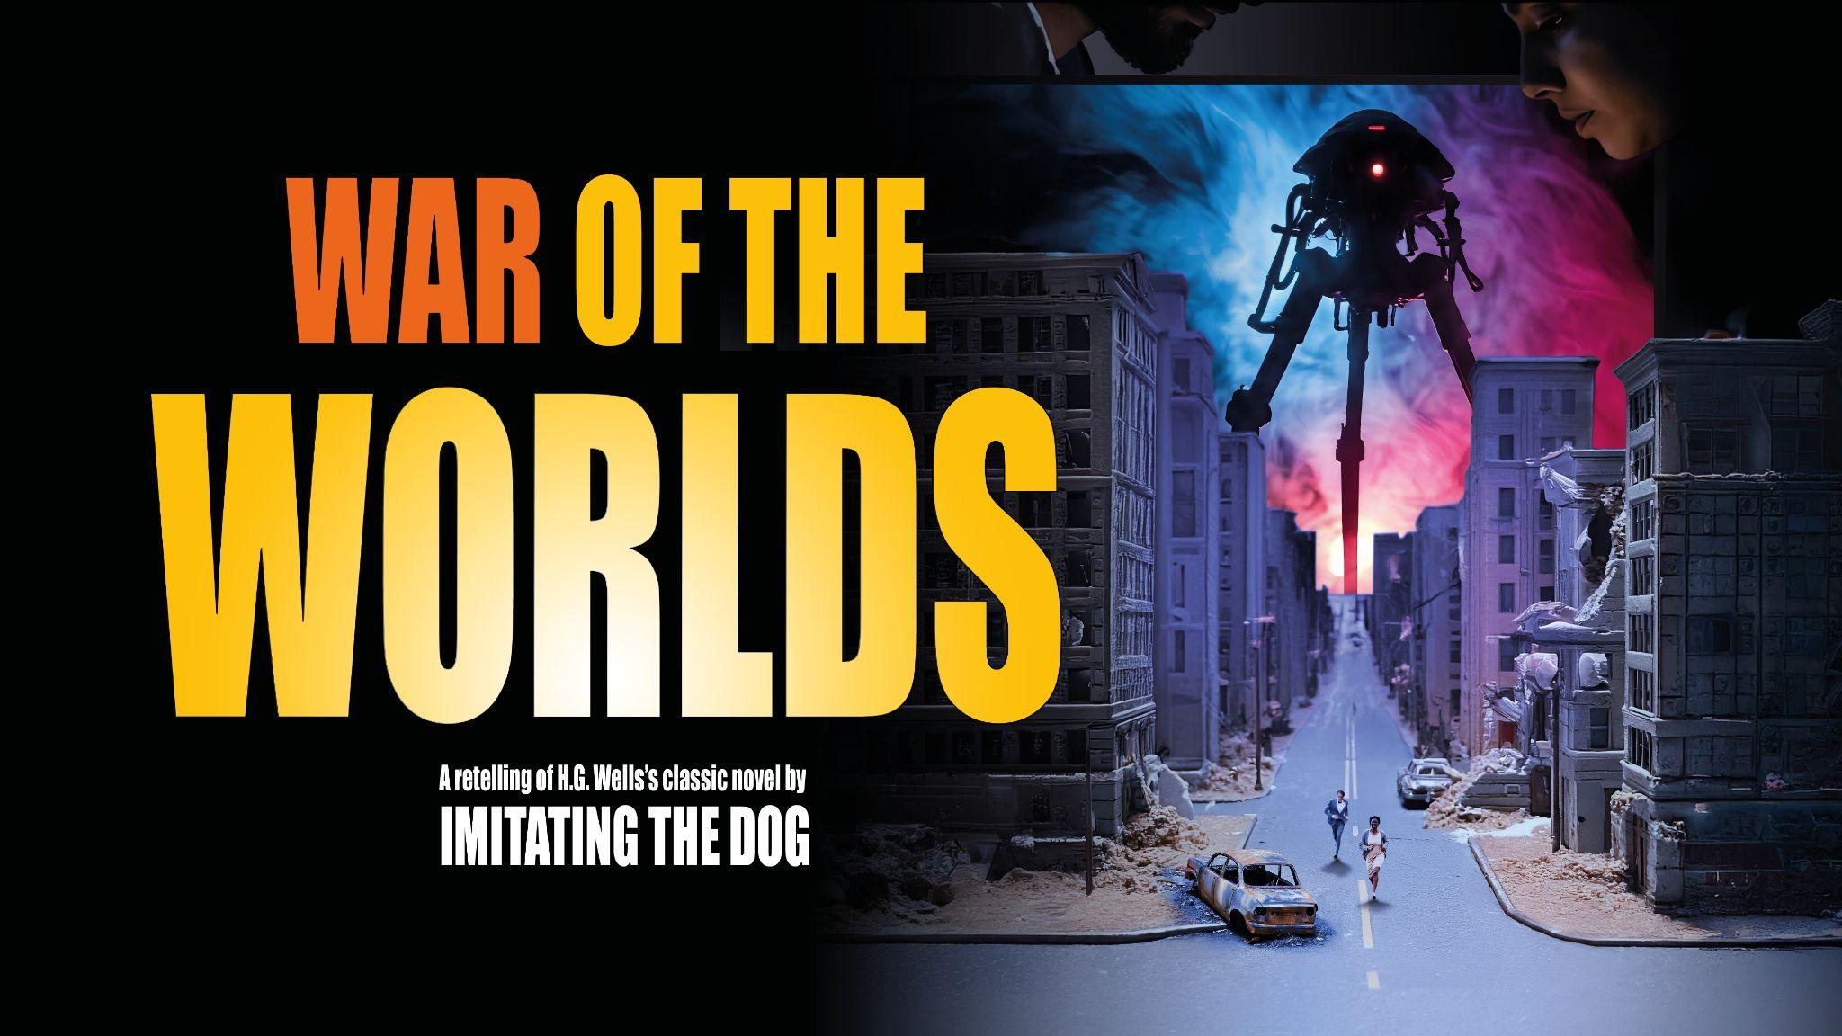

We have created a [**FREE Learning Resources pack**](https://www.imitatingthedog.co.uk/learning-resource/war-of-the-worlds-learning-resources/) that is housed on our website.

This is a collection of resources connected to the production, from blogs and curriculum connections/activities to recommendations and video content. This collection is designed to shed further light on the show and encourage exploration of its themes, history, and our approaches to theatre-making, which for this production includes model worlds, live performance, projections and a mix of live and recorded footage.

There are items in here relevant to all learning ages appropriate to the show, which has an age guidance of **14+,** meaning that it will be suitable for KS3, GCSE, A-Level, College, University, Adult Learning, Interest Groups, etc.

Currently in the collection are:

* About ITD + company showreel
* Curriculum Connections

More will be added to the pack during the production and rehearsal process, which are outlined on the landing page.

And as a reminder, we also have the opportunity for schools to book chargeable workshops alongside their theatre trip: [**imitating the dog workshops**](https://www.imitatingthedog.co.uk/learning/) **Here is some suggested copy for describing the learning resources and workshop offer to schools when promoting the show and encouraging early bookings!**

*Alongside the production,* ***imitating the dog*** *have also created a collection of FREE digital learning resources. These resources provide further background and context to the creative choices made by the team during a production process, from narrative decisions in adapting the source material, to technical and visual design. They also give some background to the history of the company, as well as things to look out for in the show if you're bringing a group, and how the production links to different curriculum areas.*

*ITD's practical workshops are a fun, informative and insightful experience of the company's innovative approach to telling stories. They vary from a short introduction to mixing the visual languages of film and theatre using no technology at all, to longer sessions involving live camera feeds, projection and/or greenscreen, and storyboarding. Workshops can be adapted to a range of needs, interests and budgets, so please get in touch if you'd like to discuss possibilities.*

Previous feedback on **imitating the dog** productions from teachers, parents and students:

* “I loved listening to the Y11 students chatting about the ideas they want to try in their C3 performances. They were so inspired!”
* “Joyously and confidently irreverent, brilliantly creative, and the kids (who’ve only ever done theatre as panto) were enthralled”
* “It did a brilliant job of engaging my reluctant teenager in their GCSE text”
* From a college student – “it’s something different to what I’m used to watching in the theatre, and the way you worked the screens and the cameras into the performance blew my mind… such a great experience”
* “We loved [*Macbeth*] and are so grateful our daughter could see this production as she embarks on her GCSE revision!!”